Cointegration and ECM: GBPUSD and NZDUSD
Method 27 / Engle-Granger on log closes / one-lag ECM / Alpari D1 full available history

Study setup
Logical pair: PX=GBPUSD , PY=NZDUSD
Broker symbols: GBPUSD_i , NZDUSD_i
Snapshot: 2026-11-03_majors_alpari_D1
Timeframe: D1
Matched window: 1999-01-05 to 2026-11-02 (UTC bar dates)
Matched level count n: 7203
Dropped unfinished last bar dated 2026-11-03 UTC after a tick-volume check against the prior complete day.
ECM lags of deltas: 1
Complete matched rows (Excel): GBPUSD-NZDUSD_Coint_D1.xlsx
Complete matched rows (HTML table): GBPUSD-NZDUSD_Coint_D1_data.html

Method carried forward
Engle-Granger cointegration works on log price levels, not returns. For each unordered pair, PX is the left leg and PY the right leg. Step one: OLS ln(PY) = alpha + beta * ln(PX) + e. Step two: statsmodels Engle-Granger coint test on (ln(PY), ln(PX)). Error-correction: delta ln(PY)_t = c + kappa * e_{t-1} + lagged delta ln(PY) and delta ln(PX) (one lag each) + u_t. Headline is the Engle-Granger p-value (lower = stronger evidence of a stationary spread) with kappa and beta reported alongside. Same-sample Pearson r of log returns is a side check only. beta is not an automatic lot-size hedge. This is not a trading signal.

Results (headline)
alpha: -0.563759
beta: 0.314598
Engle-Granger t: -1.864708
Engle-Granger p: 0.597793
5% critical value: -3.336979
ECM kappa: -0.000977
kappa t-stat: -1.8487
ECM R^2: 0.000829
spread std: 0.170437
Pearson r (returns): 0.530079

Conclusion
Engle-Granger for PY=NZDUSD on PX=GBPUSD: beta=0.3146, alpha=-0.5638, coint_t=-1.8647, p=0.5978 (5% crit=-3.3370). ECM kappa=-0.0010 (t=-1.85). Pearson r of returns = 0.5301. beta is not a lot-size hedge. Not a trading signal.

Charts
Daily closes

Engle-Granger residual spread
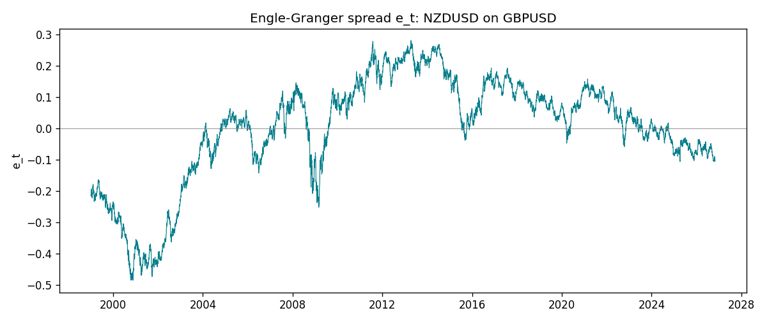
Daily log returns
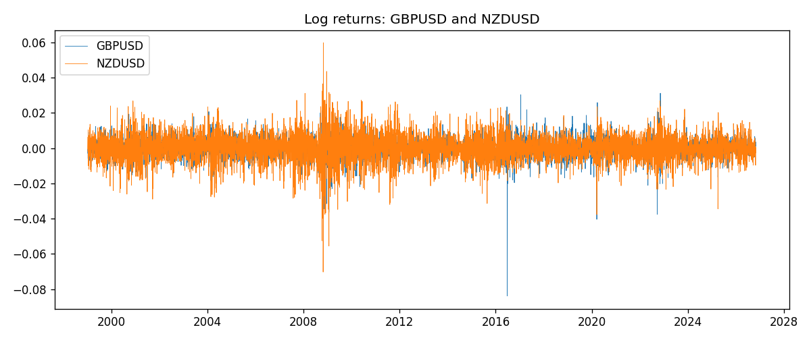

Data report
Matched rows are in the sibling Excel workbook named GBPUSD-NZDUSD_Coint_D1.xlsx. Embedding all rows as a Word table is impractical; this file holds column summaries and the first and last 15 matched rows.
Column summaries
column | count | mean | std | min | 25% | 50% | 75% | max
GBPUSD_open | 7203 | 1.5160351 | 0.21820856 | 1.06854 | 1.32502 | 1.51126 | 1.63163 | 2.1066
NZDUSD_open | 7203 | 0.65617721 | 0.10827592 | 0.3913 | 0.59107 | 0.6683 | 0.72469 | 0.88218
GBPUSD_high | 7203 | 1.5223294 | 0.21877071 | 1.08366 | 1.3298 | 1.51797 | 1.63833 | 2.1161
NZDUSD_high | 7203 | 0.66009189 | 0.10877133 | 0.3961 | 0.594565 | 0.67188 | 0.729235 | 0.88421
GBPUSD_low | 7203 | 1.5097156 | 0.21743942 | 1.03518 | 1.319525 | 1.50315 | 1.62431 | 2.0983
NZDUSD_low | 7203 | 0.65248767 | 0.1078698 | 0.3897 | 0.587935 | 0.66402 | 0.72082 | 0.87988
GBPUSD_close | 7203 | 1.5161019 | 0.21816437 | 1.06879 | 1.32515 | 1.51122 | 1.63196 | 2.1065
NZDUSD_close | 7203 | 0.65624807 | 0.10827144 | 0.3907 | 0.591395 | 0.6683 | 0.724915 | 0.8822
GBPUSD_tick_volume | 7203 | 94800.961 | 153533.35 | 62 | 9991 | 52873 | 91772.5 | 1273370
NZDUSD_tick_volume | 7203 | 68552.383 | 123030.52 | 16 | 5500.5 | 33815 | 58467.5 | 1127682
GBPUSD_spread | 7203 | 26.976121 | 19.194852 | 0 | 11 | 20 | 50 | 50
NZDUSD_spread | 7203 | 30.373178 | 25.676979 | 0 | 9 | 17 | 50 | 80
GBPUSD_real_volume | 7203 | 3.5551025e+09 | 8.4426509e+10 | 0 | 0 | 0 | 0 | 2.4038164e+12
NZDUSD_real_volume | 7203 | 1.6657093e+10 | 8.4881524e+10 | 0 | 0 | 0 | 0 | 2.705649e+12
GBPUSD_log_price | 7203 | 0.40609909 | 0.14082248 | 0.06652717 | 0.28152566 | 0.41291727 | 0.48978175 | 0.7450278
NZDUSD_log_price | 7203 | -0.43600088 | 0.17610118 | -0.93981528 | -0.52527113 | -0.4030181 | -0.32170087 | -0.12533649
GBPUSD_log_return | 7203 | -2.372e-05 | 0.00564203 | -0.08388241 | -0.00312422 | 3.221e-05 | 0.0031735 | 0.03112653
NZDUSD_log_return | 7203 | 5.29e-06 | 0.00764545 | -0.07027433 | -0.00426254 | 0.00021291 | 0.00457891 | 0.05966839
spread_e | 7203 | -0 | 0.17043741 | -0.48595114 | -0.07216463 | 0.03090628 | 0.11743312 | 0.28082354
ecm_fitted | 7202 | 5.54e-06 | 0.00022019 | -0.00086149 | -0.00014293 | -2.104e-05 | 0.00012052 | 0.00144304
First 15 matched rows (selected columns)
time | GBPUSD_log_price | NZDUSD_log_price | spread_e | GBPUSD_log_return | NZDUSD_log_return
1999-01-05 | 0.50361972 | -0.62138481 | -0.21606378 | -0.0028966287 | -0.0018597736
1999-01-06 | 0.5030152 | -0.61933925 | -0.21382804 | -0.00060452184 | 0.0020455609
1999-01-07 | 0.50089649 | -0.61304294 | -0.20686518 | -0.002118709 | 0.0062963171
1999-01-08 | 0.49500107 | -0.6135969 | -0.20556445 | -0.0058954193 | -0.00055396548
1999-01-11 | 0.48931594 | -0.60330648 | -0.19348549 | -0.0056851331 | 0.010290425
1999-01-12 | 0.49158164 | -0.60862223 | -0.19951403 | 0.0022657001 | -0.0053157489
1999-01-13 | 0.50071468 | -0.61859645 | -0.21236149 | 0.0091330396 | -0.0099742238
1999-01-14 | 0.50265231 | -0.6187821 | -0.21315672 | 0.0019376331 | -0.00018564931
1999-01-15 | 0.50089649 | -0.61952504 | -0.21334728 | -0.0017558204 | -0.00074294208
1999-01-18 | 0.50210773 | -0.62138481 | -0.21558811 | 0.0012112405 | -0.0018597736
1999-01-19 | 0.50398226 | -0.61952504 | -0.21431806 | 0.0018745281 | 0.0018597736
1999-01-20 | 0.49907688 | -0.61544567 | -0.20869547 | -0.0049053846 | 0.0040793678
1999-01-21 | 0.50222878 | -0.61138288 | -0.20562426 | 0.0031518998 | 0.0040627941
1999-01-22 | 0.50470694 | -0.62343457 | -0.21845557 | 0.0024781662 | -0.012051689
1999-01-25 | 0.50591358 | -0.62698498 | -0.22238559 | 0.0012066366 | -0.0035504102
Last 15 matched rows (selected columns)
time | GBPUSD_log_price | NZDUSD_log_price | spread_e | GBPUSD_log_return | NZDUSD_log_return
2026-10-13 | 0.28166903 | -0.57755321 | -0.10240682 | 0.0036434319 | 0.0047326165
2026-10-14 | 0.27675256 | -0.58128385 | -0.10459076 | -0.0049164679 | -0.0037306483
2026-10-15 | 0.2833502 | -0.57652037 | -0.10190288 | 0.0065976411 | 0.0047634855
2026-10-16 | 0.28710941 | -0.57077027 | -0.097335419 | 0.0037592051 | 0.0057501001
2026-10-19 | 0.28535938 | -0.56887856 | -0.094893149 | -0.0017500314 | 0.0018917133
2026-10-20 | 0.29095172 | -0.56515862 | -0.092932557 | 0.0055923442 | 0.0037199341
2026-10-21 | 0.29219935 | -0.56206629 | -0.090232728 | 0.0012476328 | 0.0030923331
2026-10-22 | 0.29242331 | -0.56536981 | -0.093606708 | 0.00022396082 | -0.0033035227
2026-10-23 | 0.29030862 | -0.56227683 | -0.089848443 | -0.0021146949 | 0.0030929853
2026-10-26 | 0.28787455 | -0.56517622 | -0.091982083 | -0.0024340661 | -0.0028993932
2026-10-27 | 0.28550971 | -0.56544022 | -0.091502106 | -0.0023648393 | -0.00026399852
2026-10-28 | 0.2870869 | -0.57516861 | -0.10172668 | 0.0015771808 | -0.0097283914
2026-10-29 | 0.29067509 | -0.5745467 | -0.10223361 | 0.0035881935 | 0.00062190714
2026-10-30 | 0.29202015 | -0.57435132 | -0.10246139 | 0.0013450605 | 0.00019537668
2026-11-02 | 0.29311727 | -0.57694762 | -0.10540284 | 0.0010971256 | -0.0025962955

